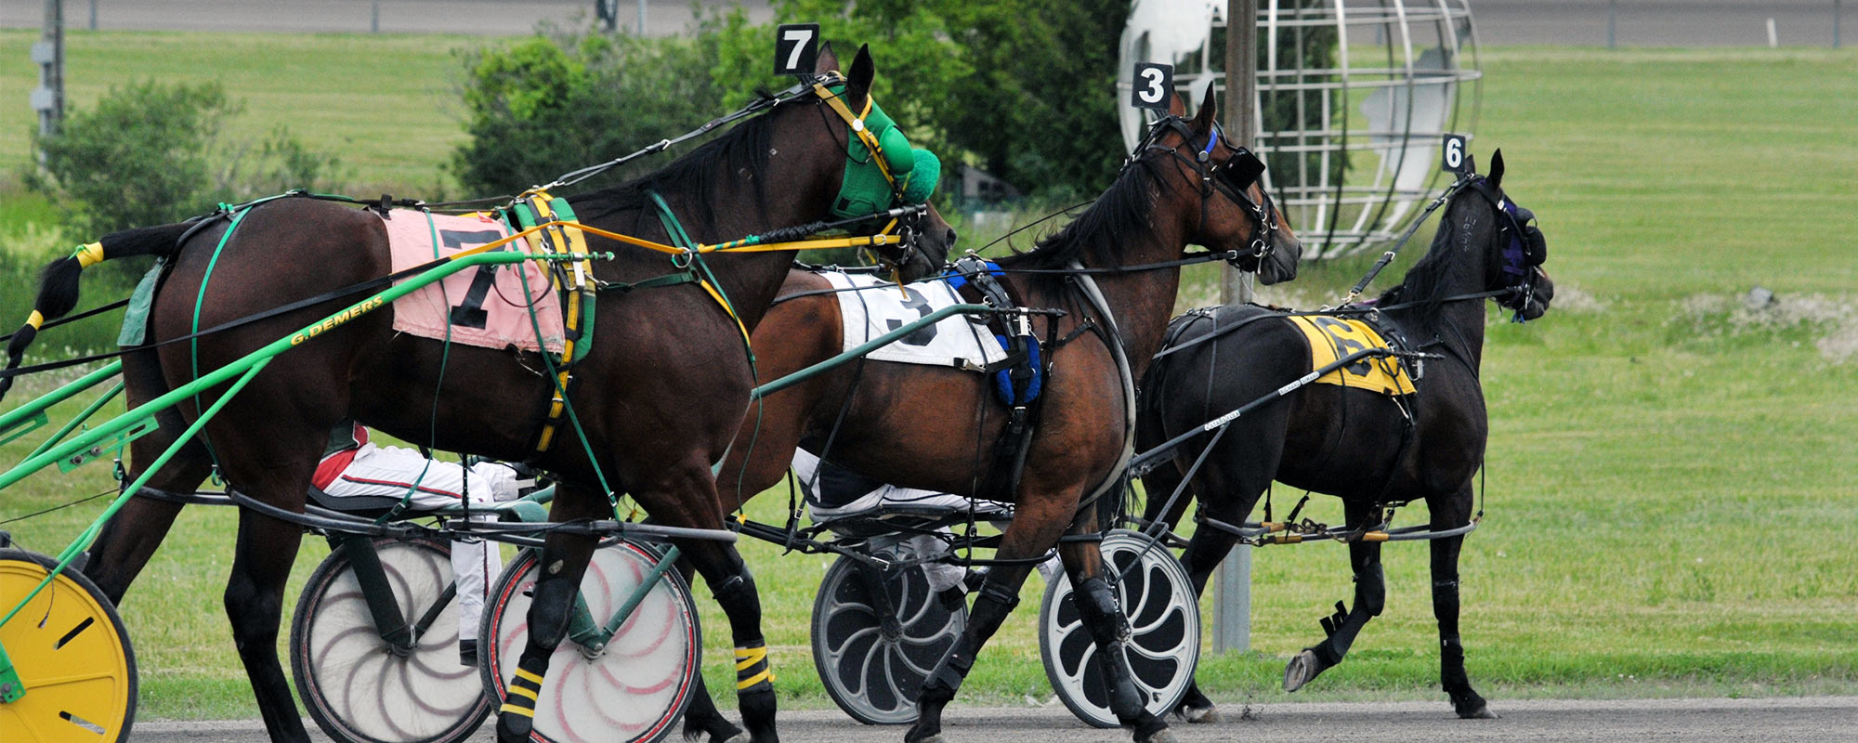

Rideau Carleton Raceway

Racing Operational Protocols during COVID-19 Pandemic
March 2, 2022
(Amended)

Rideau Carleton Raceway
Racing Operational Protocols during COVID-19 Pandemic
February 2, 2022
Preamble
Rideau Carleton Raceway is fully committed to ensuring the health and safety of all participates by mitigating manageable risks while racing during the COVID 19 Pandemic. The following document delineates the enhanced operational policies and procedures Rideau Carleton Raceway shall adopt while hosting live events and qualifiers. They have been developed in collaboration with the NCRHHA, Ottawa Public Health, Ontario Racing and our various governing bodies. Due to the fluidity of the crisis; amendments will be adopted to address changing circumstances.
Article I – Spectators (subject to prevailing Ontario regulations)

Open at 50 per cent capacity indoors.

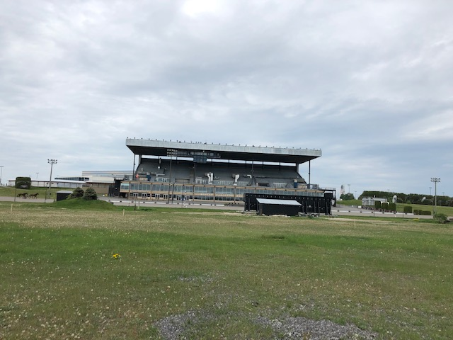
Article II - Access to the Backstretch (Main Gate)
Only essential personnel for the conduct of training, qualifiers or live racing will be granted access into the backstretch perimeter unless intending on submitting a claim; to be determined by security personnel at the main gate.
Access will only be granted after a mandatory pre-screening that will include:
. Presentation of applicable AGCO credentials.
. Evidence of a temperature below 100.5 degrees determined by a No Touch Forehead Thermometer.
. Evidence of possession of a personal protective face mask.
. Evidence of possession of a functioning mobile phone device.
. May be required to respond to the following questions below.
. Providing one’s name, e-mail/phone contact and sign off commitment to RCR’s Covid Protocols.
1. Have you or someone you have come in contact with travelled or returned from any country outside of Canada?
2. Are you experiencing, or have you experienced any of the following symptoms in the past 7 days or been in contact with:
a. Fever
b. Cough
c. Muscle Aches and Tiredness
d. Difficulty Breathing
3. Have you or someone you have come in contact with travelled or returned from any United States Racetrack or Racing Association in the past 14 days?
4. Are you aware that washing your hands multiple times per day is the most important way to stop the spread of the Coronavirus? Please use our hand washing stations at every opportunity located throughout the backstretch.
Access will be granted if the answer is no to the first 3 questions. For those who have traveled to the US or have been in contact with someone from the US in the previous 14 days: Security will record their name, date of return, contact info and State (s) they or their contact has come from. Anyone traveling outside Canada within the past 14 days may be denied access. Those who have had contact with someone residing outside of Canada in the last 14 days may be denied access depending on the severity of the pandemic of the contact in question.

Contact Tracing
All names compiled by backstretch security during each live/independent qualifying event will be filed and preserved for 8 weeks.
Article III – Paddock Protocols
ONLY HORSES ENTERED TO RACE, OR QUALIFY ON A DATE INDEPENDENT FROM A LIVE DATE ARE PERMITTED ACCESS IN THE PADDOCK.
Evidence of full COVID vaccination 2 shots (new): Presented to security at the entrance of the backstretch.
At all times, physical distancing of 2M is suggested.
Stalls will be assigned to ensure all horses under the purview of each trainer are bundled. Adjacent stalls between trainer’s bubbles must be empty to facilitate physical distancing. The following will be adhered to accommodate this requirement:
. No more than 15 races will be scheduled per day. Any stall occupied by more than one horse from a different trainer’s bubble in a given evening will be sanitized by the paddock clean team prior to granting the next horse entry into said stall.
. Stall assignment will be strictly adhered too; no exceptions will be granted.
. Only essential personnel will be permitted in the paddock.
Other than the Paddock, Starting & Equipment Judge, access to the Paddock Office is strictly prohibited.
Contact with the Paddock Judge will only be available outside the Paddock Office, respecting physical distancing; or through a filtered communication portal at the office window.
Contact with the AGCO Judges during a live event will only be through individual mobile phones. Shared communication devices is prohibited.
Horses parading for the oncoming race will do so via the north door of the paddock.
The dressing room will be available to a maximum of 2 people at any time. Masks must be worn at all time. Please do not loiter.
The backstretch kitchen may open on live nights; while complying with mandatory mask rules for everyone not actively eating. Consumption on food inside the horse Paddock is prohibited.
All those entering the paddock must wear a personal protective mask.
Grooms paddocking for multiple trainers should register with the Paddock Judge at the start of the event to avoid any misunderstandings and sanitize before proceeding from one training bubble to another.
Horsepeople will be required to justify arriving more than 2 hours prior to their scheduled race. Exceptions must be merited and will not be granted for convenience. Examples of exceptions would include, but not limited to, shipping multiple horses in your trailer.
Horsepeople are required to vacate the Paddock within a half hour of their last race.
Hand washing stations will also be located throughout the paddock.
Paddock washroom doors are to remain open when not in use to facilitate venting.
Masks must be worn at all times while accessing the paddock blacksmith’s shop. Please respect physical distancing.

Article IV - Track Maintenance
All maintenance vehicle cabins are to be disinfected at the start and end of each event.
No vehicle will accommodate more than one operator and no employee will crossover any assigned vehicle for that event.
Access to the track shack is strictly prohibited to anyone other than the Track Maintenance Staff.

Article V - Claims
Access to the casino/grandstand on the opposite side on the track is strictly prohibited, as are the parking lots. Claims are to be submitted in a provided envelope through a designated slot at the Paddock office. It is the responsibility of the applicant to ensure the form is properly filled out and the proceeds are correct or the claim will be rejected. Claims in envelopes that are wet sealed will be rejected. Those making claims will be granted temporary access in the paddock to make their claim and collect their horse and will be required to meet the same entrance criteria listed above. Anyone granted access for a claim will not be permitted to loiter and claim activity will be accessed to ensure that this privilege is not abused.

Article VI - Cleaning Protocols
Additional cleaning protocols including the increased frequency of high-risk surfaces will be adapted including toilets, gates and paddock office vicinity. Hard Rock Ottawa will also be providing education and training for employees.
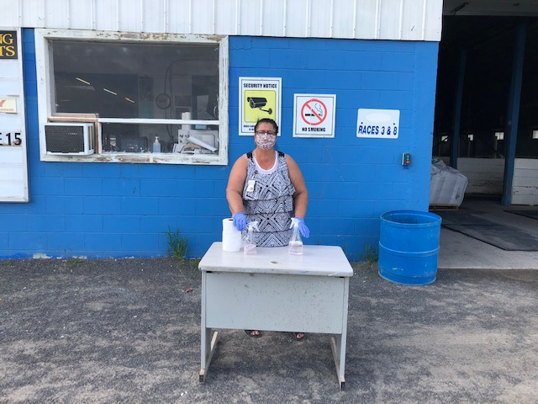
Hands must be washed every time you enter the Paddock.

Article VII – Testing
The wearing of masks at all times while in the retention area is mandatory.
- Cloth and surgical-style face masks that enclose the nose and mouth are acceptable. Scarves and bandanas are not acceptable face coverings.
- Please note that proper hand hygiene (hand washing) continues to be of utmost importance.
Racetracks will assign a person to control access to the retention area and ensure appropriate masks are worn.

Changes to usual procedures:
- A maximum of two people may enter the retention area with a horse called to test.
- Every effort must be made to keep at least two meters (six feet) between people at all times.
- Horses must be attended by at least one horseperson at all times.
- Retention time will be reduced to 40 minutes (from 60 minutes).
  - For clarity, the official retention time before drawing a blood sample is 40 minutes from time of entry to the Retention Area.
- Horsepersons are requested to keep cooling out and bathing time to a minimum.
- Horsepersons should only touch their own horse and equipment, and may touch wash stall cross-ties, hoses and faucets. Retention area staff will open and close all doors as needed.
- Horsepersons will provide their name and license number to the Test Inspector in lieu of a signature as witness to the sample collection.
- Horsepersons may not enter the stall with the Test Inspector and horse unless specifically requested by the Test Inspector. They may witness sample collection via the peephole if the stall door is closed.
- Horsepersons may not enter the office and/or sample processing areas. They may witness sample processing from designated areas.
- Horsepersons must stand on the opposite side of the horse from the Test Inspector during blood collections.
- Seal side human entrance into the retention area. Horses and people must enter through the door at the end of the retention area.
- Remove bench from retention area that is currently placed under the office window.
- Replace with a 2’x4’ table with plexiglass installed on the end to allow horsepeople to witness the sealing and labeling of samples if desired.
- Provide some form of wash station for TCO2 technicians
- 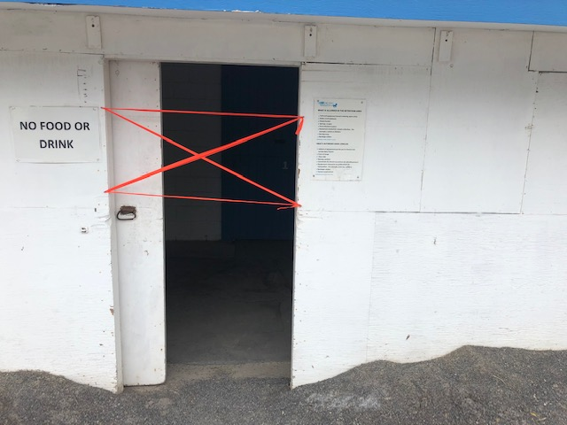 To deter people from entering the test barn by the side while not impeding fire escape protocols.

Article VIII – Judging
The AGCO judge’s office in the backstretch will be closed. Required communication with racing participates will be at the discretion of the designated AGCO judge utilizing devices appropriate to facilitate physical distancing (eg. Phone, video conferencing, ect.)
Plexiglass will separate the two AGCO judges in the gondola, while each station will be disinfected after each event. 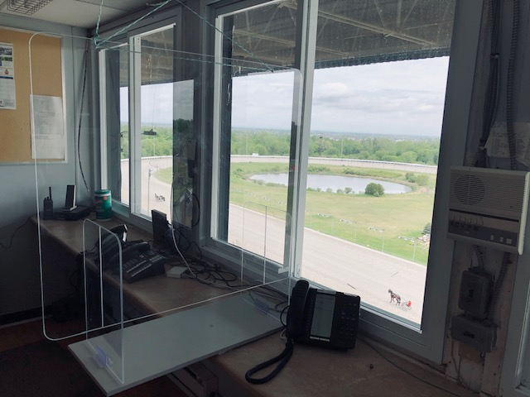
AGCO Judge’s stand in the gondola

Plexiglass will be installed in the licensing office and queuing lines will be on the floor to address distancing. This office will also be disinfected after each event.

Article IX - General Protocols
. Access to the viewing shelter is strictly prohibited, except for the attending veterinarian.
. No winning circle pictures will be taken, therefore obviating the need to ferry anyone in the van.
. A foil will be installed in the pace car to separate the starting judge and driver.
. Rideau Carleton Raceway reserves the right to cancel a race date if significant and persistent rainfall is forecasted.
. A patrolling marshal will be assigned to ensure compliance of these protocols and physical distancing.
. To minimize traffic, qualifiers will be scheduled independent of a live event.
. The paddock will be disinfected after each event.
. The track will be limited to 10 horses for training during two designated blocks from 7:30 AM to 9:30AM and 9:30 AM to 11:30 AM. Reservations are required and all entrants must satisfy the same criteria delineated in Article II. The paddock will not be available for training; trainers may use the outside stalls in the stake barn or inside stall of the ship in side. Those stabled at Rideau Carleton Raceway have unrestricted access to the race track while open.
Article X - Violators
Anyone who refuses to follow proper safety procedures, and or acts in a manner that may increase the risks of COVID-19 exposure or infection will be trespassed from the property. Well beyond education, any violation will first come with a warning and any subsequent violation will result in the suspension of the culprit’s access to the backstretch for 1 week, 3 weeks then indefinite. NCRHHA will be notified of any horse person suspension.
Article XI – Positive Test
In the event that Rideau Carleton Raceway becomes aware that a person who has tested positive for COVID-19 has been in attendance at the track, RCR will notify all employees and participants who may have been exposed. The track will ensure that the infected person does not re-enter the premises until either (i) at least 5 days after symptoms have subsided, or (ii) the person is able to provided evidence of a negative test and clearance from a doctor to return to work. Rideau Carleton will encourage any person who may have come into contact with the infected person to be tested for the virus and will follow any guidance provided by public health authorities.
Acknowledged and Consent

Peter Andrusek
Racing Manager
Rideau Carleton Raceway

Acknowledged and Consent

Gordon McDonald
President
NCRHHA

